**Introduction to Mobile Development**

MODE4201 – 02

Lab #1



Peter Wolfgang Linder

100548586

**Table of Contents**

How Does Mobile Computing Affect Individuals? Page: 2

Mobile Manufacturers: Pages: 3-4

Mobile Plans: Pages: 5-6

References: Page: 7

**1. How Does Mobile Computing Affect Individuals?**

The introduction of mobile computing and eventually, internet-access to the broad consumer market has connected us globally. Communication and information are now instantly available to us at any moment. drastically changing how we interact with the world around us.

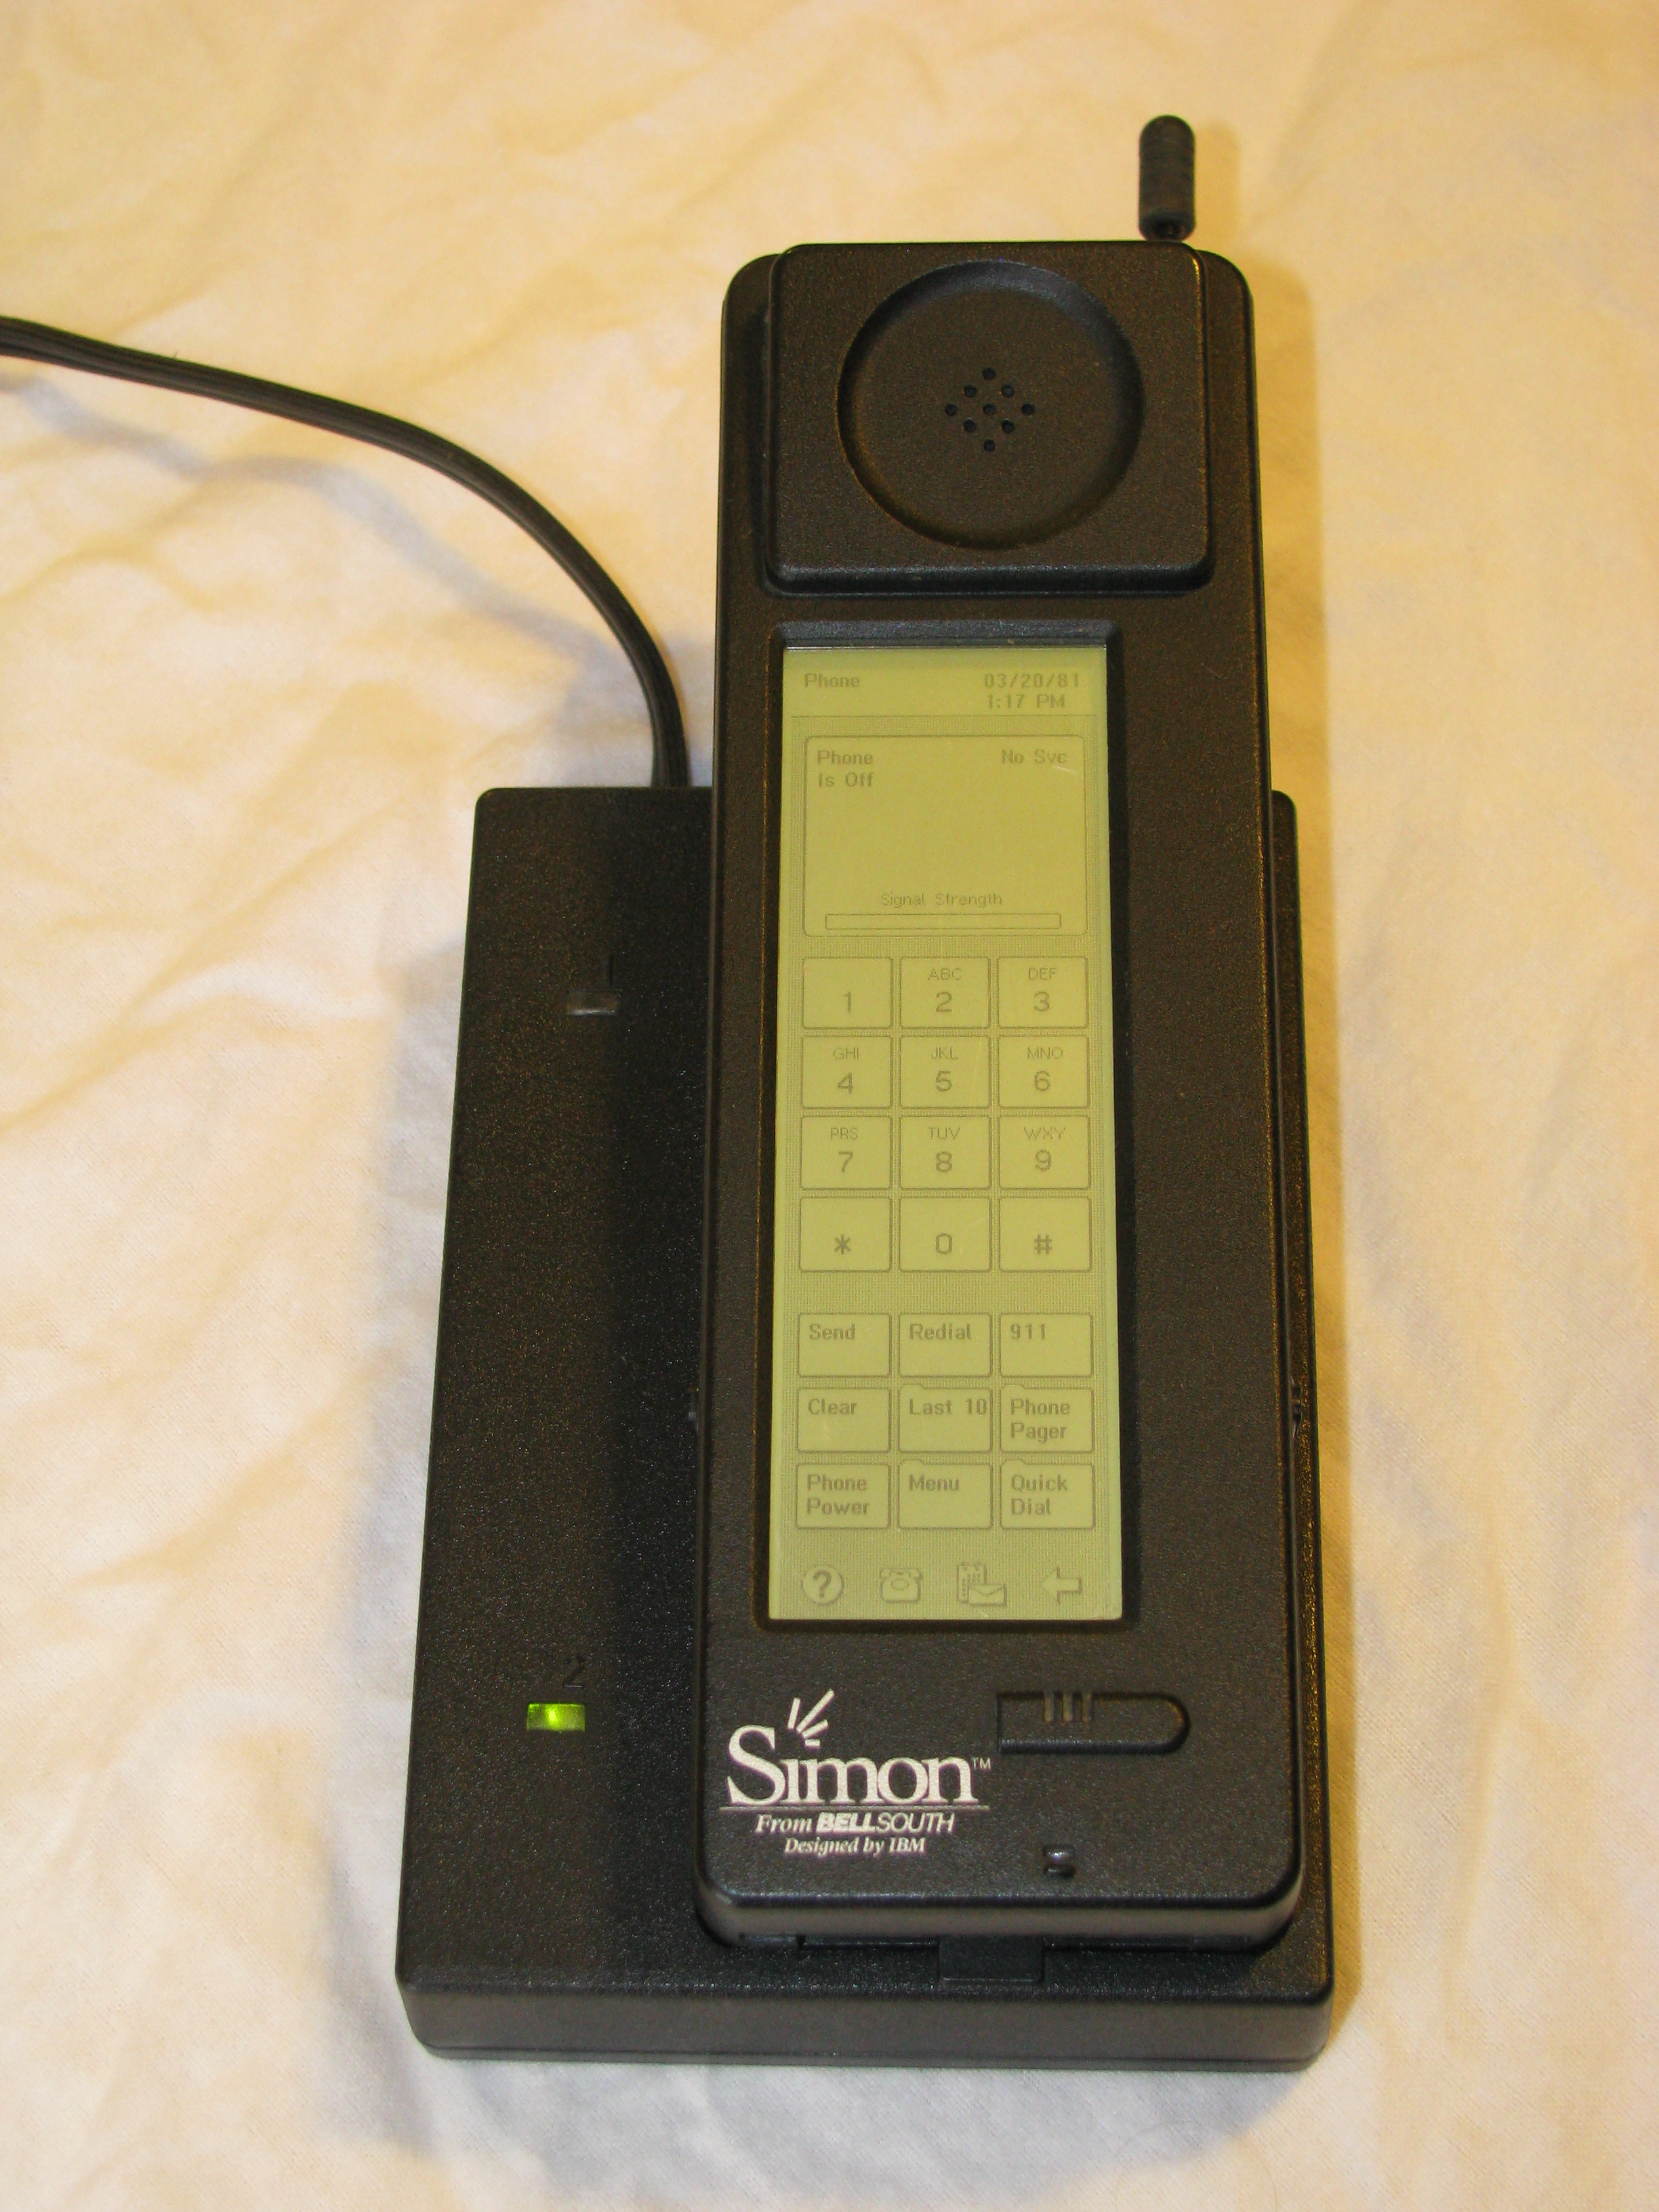

Wireless telephones have been available since the 80s. They were particularly expensive and had to make tradeoffs in bulk or battery life – not the most practical.

In 1994, before the coining of the term ‘smartphone’, IBM released SIMON for commercial sale. SIMON featured a global clock, calendar, pager, email and fax functionality, and could be considered the first ever ‘smartphone’. Its initial price, adjusting for inflation, would have cost $1800 USD today. This was definitely a business tool, and we saw that perception towards mobile phones reflected in their limited adoption in the coming decade.

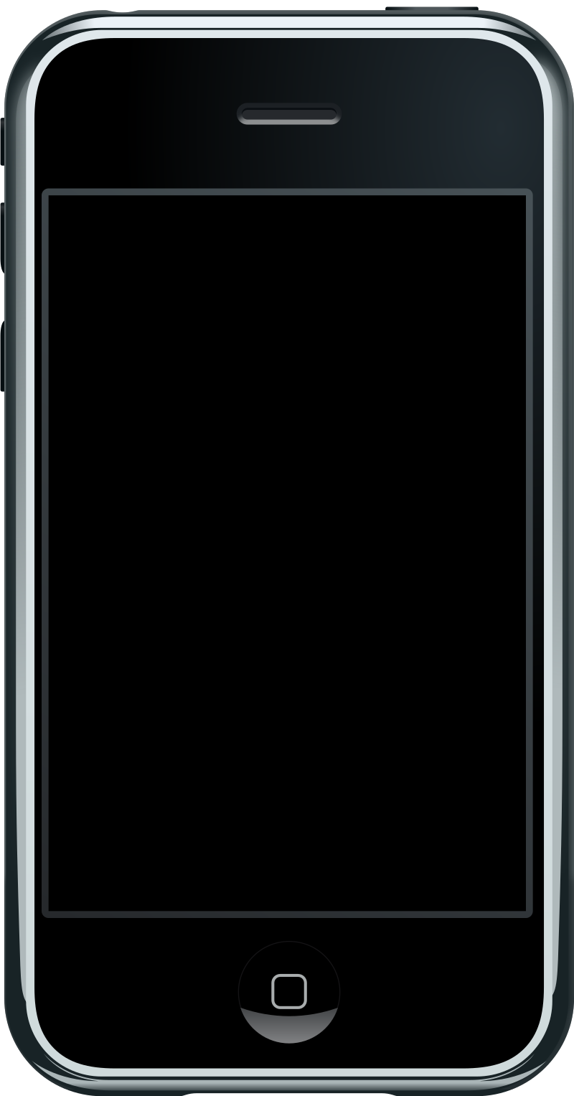

The first 3G networks were launched in 2001. With a minimum of 144kbits, the internet could be used for video-conferencing or file transfer. It was in 2007 though, with the announcement of the iPhone, that smartphones would see mass adoption.

Early smartphones used keypads, which were convenient for typing, but took up too much screenspace. The iPhone had an entirely touch-screen interface, allowing users to browse the internet similar to how they would a desktop computer. It was also advertised to be a widescreen mp3 player and internet communicator. This is where we start to see the potential of mobile devices as computers.

In the present day, mobile devices dominate the multimedia market. Mobile gaming is a billion dollar industry, Social applications and Audio/Video streaming are accessible globally. We have limitless entertainment in our pockets at the touch of a screen.

These advancements have come at the cost of degrading relationship value. Many students report feeling isolated, despite the instant access to communication. Social media use is significantly larger in this group, and they rely on technology increasingly to communicate with friends and family. We also expect to be gratified instantly. Immediate access to the internet for all of our answers has led to this expectation and a potential reduction to patience.

It’s important to see these devices as tools. They can bring us much enjoyment and improve our productivity significantly. Yet over-reliance on them can bring the inverse.

**2. Mobile Manufacturers**

|  |  |  |
| --- | --- | --- |
| **Manufacturer** | **Oneplus** | **Apple** |
| Model | Oneplus 9 Pro | IPhone 13 Pro |
| Picture |  |  |
| Price (CA) | $1,499 | $1,399 / $1549 |
| Release | April 2nd, 2021 | September 24th, 2021 |
| Operating System | OxygenOS, based on Android 11 | iOS15 |
| Chipset | X60 | A15 Bionic |
| CPU | Qualcomm® Snapdragon™ 888 | “New 6‑core CPU with 2 performance and 4 efficiency cores ”?  Hexa-core (2x3.22 GHz + 4xX.X GHz) |
| RAM | 8 / 12GB LPDDR5 | 6GB |
| Internal Memory | 128 / 256GB UFS 3.1 | 128 / 256 / 512 / 1TB |
| External Memory | No | No |
|  | Fluid AMOLED with LTPO, 120Hz,   6.7 inches,  3216 X 1440 pixels | Super Retina XDR OLED, 120Hz,   6.1 inches, 2532 x 1170 pixels /  6.7 inches,  2778 x 1284 pixels |
| Front Camera | 16 MP | 12 MP |
| Rear Cameras | Sony IMX789 50/48 MP. Telephoto Camera 8MP, Monochrome Camera 2MP | 12MP Wide, 12MP Ultrawide, 12MP Telephoto, TOF 3D LiDAR scanner |
| Network | GSM / CDMA / HSPA / LTE / 5G | GSM / CDMA / HSPA / EVDO / LTE / 5G |
| GPS | (L1+L5 Dual Band), GLONASS, Galileo (E1+E5a Dual Band),Beidou, A-GPS | A-GPS, GLONASS, GALILEO, BDS, QZSS |
| Battery | 4500 mAh | 3125 mAh |
| Default Browser | Chrome | Safari |
| Standby Battery Life | Unlisted | Up to 22 h (multimedia) |
| Charge Time | 65W, 1-100% in 29 min | 20W, 50% in 30 min |
| Wireless Charging | 50W, 1-100% in 43 min | MagSafe wireless charging 15W Qi magnetic fast wireless charging 7.5W |
| Port | USB Type-C 3.1 | Lightning, USB 2.0 |
| Audio Jack | No | No |

**3.** **Mobile Plans**

|  |  |  |
| --- | --- | --- |
| **ISP** | **Freedom** | **Speakout** |
| Plan / Billing Type | Prepaid | Prepaid |
| Pricing (CA) | Charge per transaction.  $1.25 Regulatory Charge/month | $99/year (Current Promotion)  or $19/month |
| Discounts | No | -$5/month with digital activations |
| Texts | $0.15 / outgoing text to CAN/US Incoming free | Unlimited Global |
| Calling | $.30 / min Canada-Wide | Unlimited Canada-Wide  Unlimited Incoming |
| MMS | $.50 / message (Must have active data plan) | Unlimited |
| Data | $10/month for 100mb | By the Gig or 1.5GB (Current Promotion) |
| Add-Ons | $10/month for either Unlimited Canada-Wide calling or Unlimited Texting | Additional Data Available |
| Voicemail | Yes | Yes |
| Caller ID | Yes | Yes |
| Call Waiting | Yes | Yes |
| Promotions | No | Bonus Data Yearly Billing Savings Online Activation Savings |
| Hidden Fees / Terms & Conditions | Plans (Add-Ons) renew 30 days from activation  Data usage above plan is $0.10 per MB  Taxes extra for account top-ups | A one-time connection fee of up to $35 will apply to each new line activation or phone upgrade in-store.  Promotions available for a limited time  Taxes extra |

|  |  |
| --- | --- |
| **Coverage** | |
| Speakout | Freedom |

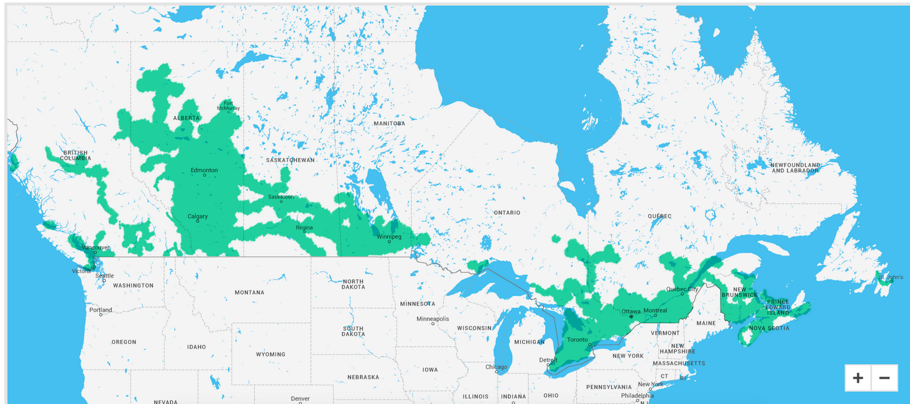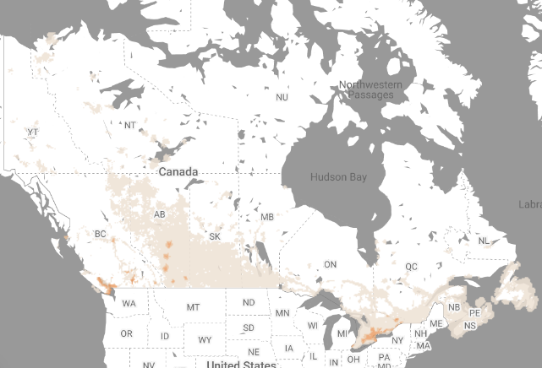

**References**

[https://sciencenode.org/feature/How%20did%20smartphones%20evolve.php](https://sciencenode.org/feature/How did smartphones evolve.php)

<https://upload.wikimedia.org/wikipedia/commons/0/0c/IBM_SImon_in_charging_station.png>

https://www.researchgate.net/publication/319212701_Effects_of_Mobile_Technology_on_Human_Relationships

https://www.apple.com/ca/iphone-13-pro/specs/

https://www.gsmarena.com/apple_iphone_13_pro-11102.php

https://www.oneplus.com/ca_en/9-pro/specs

https://www.gsmarena.com/oneplus_9_pro-10806.php

https://www.speakout7eleven.ca/prepaid-phone-features

https://www.freedommobile.ca/en-CA/prepaid-plans?planSku=Freedom%20Nationwide%20Talk%20%2B%20Text